ORGANIZER
The National Judo Federation of Kyrgyz Republic
Address: Kyrgyz Republic, Bishkek city, Togolok Moldo str. 17
Tel./Fax: +996 557 44 99 45 +996709998384 (Whats up)
Email: judo-fkgz@mail.ru

COMPETITION PLACE
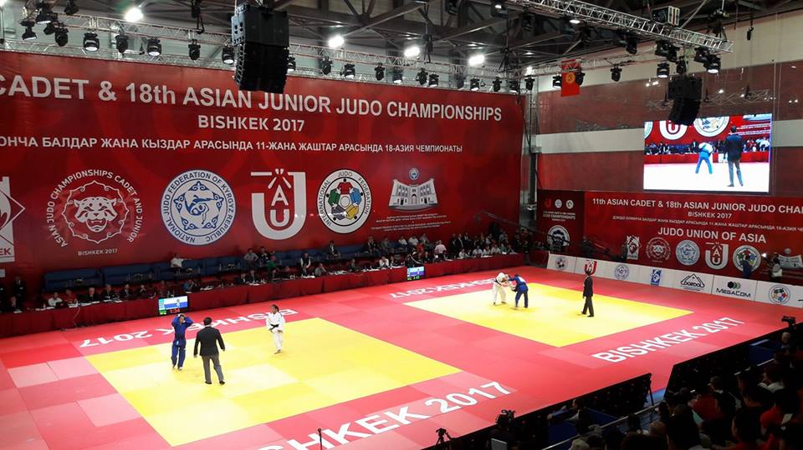
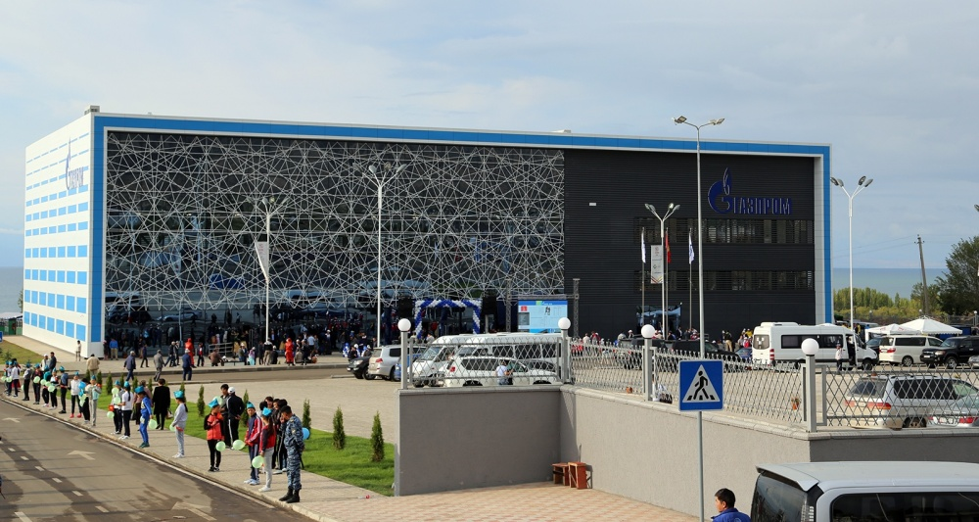

Gazprom Sport Complex
Address: Kyrgyz Republic, Issyk-Kul region, Cholpon-Ata city

ACCOMMODATION
Caprice Hotel
Kyrgyz Republic, Issyk-Kul region, Cholpon-Ata city
Distance to the venue 3,4 km
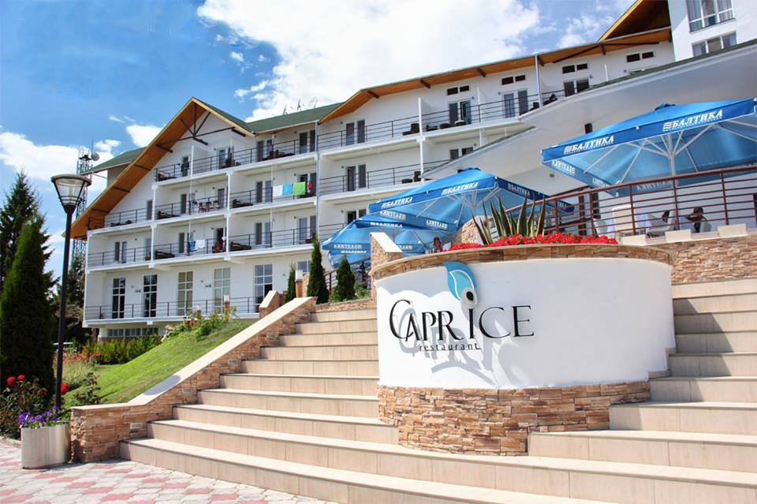
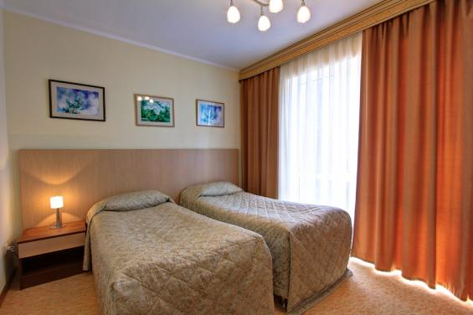

Rome rate:

Single room: 100 USD per person per night (full board)
Double room: 80 USD per person per night (full board)

Kyrgyzskoye Vzmor'ye Hotel
Kyrgyz Republic, Issyk-Kul region, Cholpon-Ata city
Distance to the venue 8,3 km
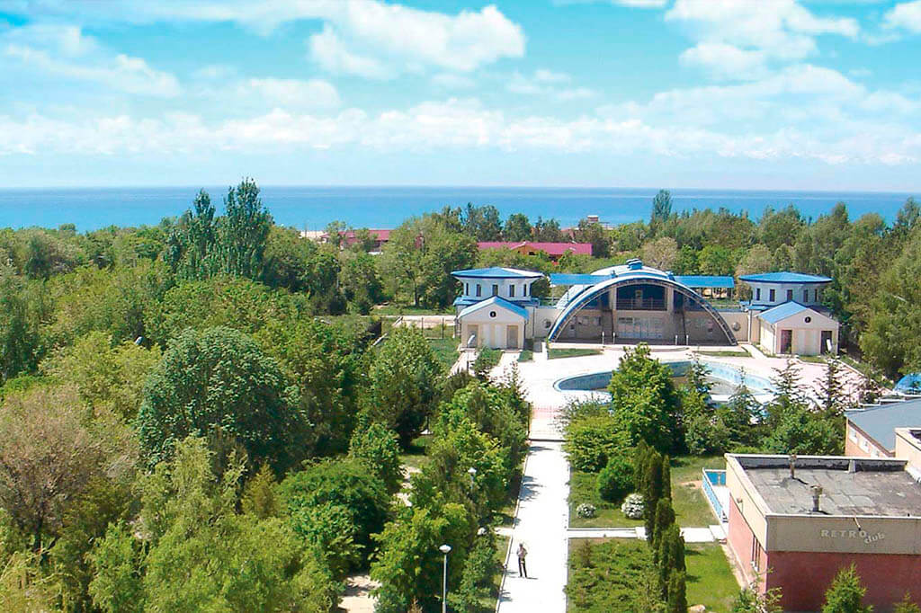
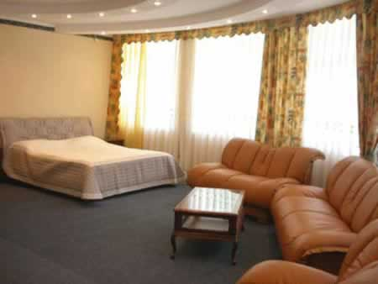

Rome rate:

Single room: 80 USD per person per night (full board)
Double room: 60 USD per person per night (full board)

Goluboi Issik-kul Hotel
Kyrgyz Republic, Issyk-Kul region, Cholpon-Ata city
Distance to the venue 3,2 km
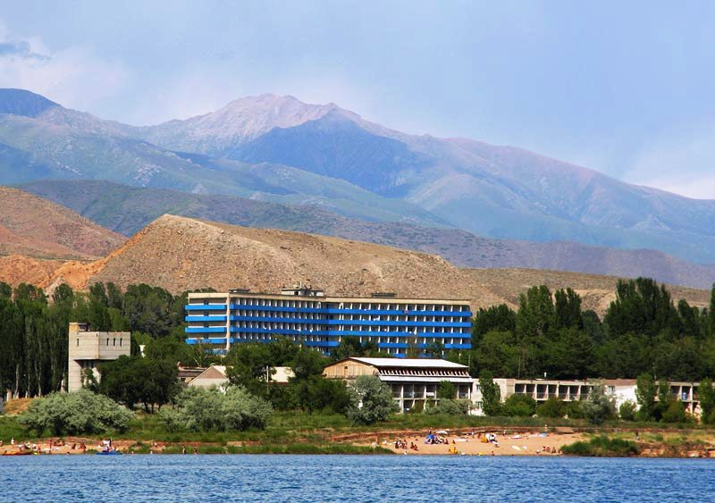
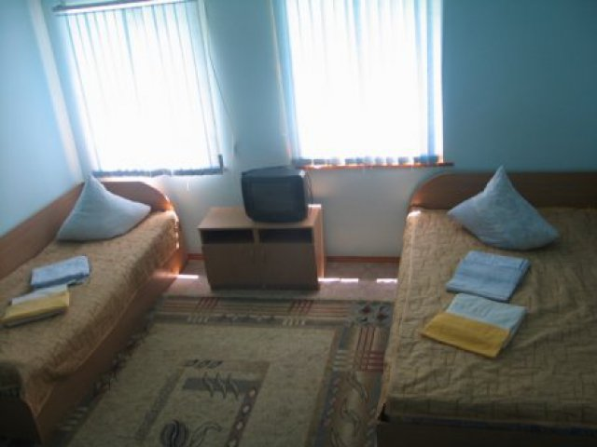

Rome rate:

Single room: 60 USD per person per night (full board)
Double room: 50 USD per person per night (full board)
For delegations which are living in non official hotel there is penalty 100 USD per person.

TRANSPORTATION
The Organizers will provide of transfer to and from and the official hotel. (The transfer from Tamchy International Airport (35 km) or Manas International Airport Bishkek must be booked directly by organizer and will have a cost $ 10,00 (ten dollars) per person per way. Service is available only the following days:
During the competitions, transportation will be provided between the venue and the hotel.

PROGRAM

Date | Time | Event | Place
22 June | 9:00-16:00 | Accreditation | Gazprom sport complex
22 June | 17:00 | Draw | Gazprom sport complex
 | 18:30-19:00 | Un-official weigh-in | Gazprom sport complex
 | 19:00-20:00 | Official weigh-in  -50 kg, -55 kg, -60 kg, -66 kg  -40 kg, -44 kg, -48 kg, -52 kg | Gazprom sport complex
23 June | 10:00-16:00 | Preliminaries, repechages  -50 kg, -55 kg, -60 kg, -66 kg  -40 kg, -44 kg, -48 kg, -52 kg | Gazprom sport complex
23 June | 17:00 | Finals and bronze | Gazprom sport complex
23 June | 18:30-19:00 | Un-official weigh-in | Gazprom sport complex
23 June | 19:00-20:00 | Official weigh-in  -73 kg,-81 kg, -90 kg, +90 kg  -57 kg,-63 kg, -70 kg, +70 kg | Gazprom sport complex
24 June | 10:00-16:00 | Preliminaries, repechages  -73 kg,-81 kg, -90 kg, +90 kg  -57 kg,-63 kg, -70 kg, +70 kg | Gazprom sport complex
24 June | 17:00 | Finals and bronze | Gazprom sport complex
25 June |  | Departure delegations

- INSURANCE
Each National Federation is responsible for its competitors (the control of non-pregnancy as well as the gender control are placed under the responsibility of the National Federations) and must assume all responsibility for accident and health insurance as well as the civil liabilities for their competitors and officials, during the Competition.
The organizer and JUA will not be responsible for any insurance related to the above mentioned matters. Nevertheless the National Judo Federation staging the competitions shall take all necessary actions to provide insurance coverage against civil liability for the entire duration. Time Activity Place

DEADLINE FOR APPLICATIONS
Visa Entry: 10 May 2018
First Entry (entry by number): 01 May 2018
Travel information: 20 May 2018
Final Entry (judobase.org) 20 May 2018
Hotel reservation: 20 May 2018

PARTICIPATION
All the participants must have valid IJF ID card, otherwise registration for this event is not possible. This JUA Cup Juniors is open for all JUA/IJF Member Federations. There is no limit in the number of participation for each weight category for every federation. The competitors must be of the same nationality as the National Federation, which enters them. In case a Federation or a club registers an athlete with a different Nationality, a confirmation letter from the National Federation of the country of which the athlete holds the passport should be presented during the accreditation.

COMPETITION RULES
Competition will be conducted in accordance with the IJF and JUA Sports and Organization Rules, and IJF Refereeing Rules.

Men & Women – Four (4) minutes (Real Time)
The “Golden score” with no time limit. Referee’s decision is cancelled.

REFEREES
Each participating countries may enter TWO (2) referees at maximum. Referees must have IJF International or Continental Referee License.

WEIGH-IN
Weigh-in will be conducted one evening prior the event.
Athletes are not allowed to weigh-in naked. Boys must wear at least underwear and girls at least underwear and a T-shirt. Additional 100g will be allowed for their weight category limits.

Athletes must present accreditation card, IJF ID card and his/her passport (National ID Card showing nationality and date of birth are also accepted).

- DRAW
- The draw will be conducted at 17:00 on 22 June in Gazprom sport complex
- Each National Federation must send a delegate to attend the Draw, a maximum of three
(3) delegates per National Federation (2 officials and 1 athletes’ delegate) will be authorized.

JUDOGI

Approved Judogi

All Judoka must compete in IJF Approved Judogi (supplied by one of the following manufacturers: Greenhill, SFJAM NORIS, DANRHO, MIZUNO, Double D Adidas, HAYAKAWA, Fighting Film, Budo Sport AG, ESSIMO, MATSURU B.V.).

Judogi Control

It will be operated with a Sokuteiki prior to the fight. Judogi must have an IJF Official Label “APPROVED JUDOGI” with an optical code which cannot be falsified. The label can be controlled with an optical lamp. Each of the competition clothing articles (jacket, trousers and belt) must have an IJF official label.

Backnumber

Each competitor taking part in the JUA/IJF events is obliged to have sewn on the back of his Judogi the official IJF backnumber bearing his surname and his National Olympic Committee abbreviation. The backnumber can be ordered from www.ijfbacknumber.com or www.mybacknumber.com (Attention: production and delivery takes around 4 weeks). The SPONSOR part (if needed) will be given to the head of delegation during registration, and the athletes can stick it themselves using the special glue on the back number.

National Emblem


Athletes can have their national emblem on the left front part of the jacket within a space of 100cm2.

COACHING
Code of behavior of coaches as defined in the Sports and Organization Rules, Annex 4 will be
strictly observed, inclusive the Dress Code.
- Coaches are not allowed to give indications to the competitors while they are fighting.
- Only during the pause time (after matte), coaches will be permitted to give indications to their athletes. - After the pause is finished, and the fight continues (hajime), coaches will have to keep silent again.

- If a coach doesnґt follow these rules, they can be expelled from the competition area.
- If the coach persists with this behavior from outside the competition area, they could be penalized.

AWARDS AND PRIZES
1st Place – Gold Medal with Diploma 2nd Place – Silver Medal with Diploma 3rd Place – Bronze Medal with Diploma

VISA
The Organizer is happy to help any country with obtaining visa for athletes and officials. For nations, who need VISA to enter KYRGYZSTAN, please send the Organizer as soon as possible (latest 10 May 2018) list of participants according to visa application form with full names, passport numbers, date of birth, and positions (MUST send together with scanned Passport Copies).
17.TRAINING CAMP
The International Juniors and Cadets Training Camp will be held from 26 to 29 April 2018 after the competition. All the participants are allowed to take part. Accommodation should be booked in advance.
*According to the Law of Kyrgyz Republic, Judo Federation holds the liability for
the security of all the teams during her participation in Asian Open Cup in Cholpon-Ata city from 11-15 April, 2018 and the Ministry of Internal Affairs requires your accommodation at the official hotels only! Otherwise you will be back warded from the country.

Form 1: Hotel Reservation Form

Federation

Address
Email
Telephone Number

Preferred Hotel
Official Hotel | Number of Rooms |  | Type of Room | Date of Arrival |  | Date of Departure | Number of Nights | Board Basis |  | Total Amount ($)
 |  |  |  |  |  |  |  | Total
Single
Double
FB: Full Board

Please send this document, completed, to accommodation judo-fkgz@mail.ru before 20 May 2018.

DATE:
Signature of the head of the delegation and stamp of the federation

Form 2: Travel Schedule and Transfers

Federation

Email

Emergency Contact No

Travel by Plane
Date of Arrival | Arrival Flight Number | Arrival Flight Time | Originating airport | Arrival airport | No of Persons
Date of Departure | Departure Flight Number | Departure Flight Time | Departing from airport | To airport | No of Persons

Travel by Train
Date of Arrival | Train Number | Arrival Time | Originating station | Arrival station | No of Persons
Date of Departure | Train Number | Departure Time | Departing from station | To station | No of Persons

Travel by Car
Date of Arrival | Arrival Time | No of Persons | Date of Departure | Departure Time | No of Persons

Please send this document, completed, to judo-fkgz@mail.ru before 20 May 2018.

DATE:
Signature of the head of the delegation and stamp of the federation

Form 3: Visa Application Form

FEDERATION

We need the invitation from |  | till |  | May 2018
We will apply for visas in Kyrgyz Embassy in |  |  | (Country, city)
We kindly ask you to complete all columns in block letters. To arrange visas we also need a copy of the first page of the passport (where the picture is) of each participant

№ | Surname | First name (full as in passport) | Sex | Position | Date of birth | Nationality | Passport number | Date of issue | Date of expiry

Date: Signature:

PLEASE RETURN THIS FORM TO THE ORGANIZER judo-fkgz@mail.ru BEFORE 12 May 2018.

